FloodSafe Minute May 2024
Need Help Understanding the New Flood Insurance Rates?
The Flood Insurance Advocate May Have Answers

Insurance policy holders have approached the Parish for help understanding the new flood insurance rates. The Office of the Flood Insurance Advocate may be able to help people determine if their policy premium is correct. The National Flood Insurance Program (NFIP) has been redesigned through a process called Risk Rating 2.0 (RR 2.0). The program has been promoted as fair in assessing the correct rate for each individual structure. In Louisiana that means people can see rate increases of 600% or more. Insurers are struggling to work within the new online system that determines the policy rates, and the system uses default data that may not be accurate. If you have received a flood insurance policy premium that does not seem right, and your insurance agent does not see a way to explain it or reduce the cost, the Flood Insurance Advocate’s Office has a new Customer Service Branch to review the information in your policy and determine if the RR 2.0 rating system has been appropriately applied. To request a review, go to fema.gov/flood-insurance/advocate and scroll to the bottom to Ask the Advocate. Type in your question, and someone will respond to go over the policy for errors, confirm the rate, and/or recommend changes that you would bring to your agent.

Don’t think that this is a problem for you? While premiums for existing policies are going up at the usual rates, few notice that there is a discount showing on the declaration page. The Full Risk Rate showing on the policy is the full rate that the NFIP will charge for that policy. By increasing the premium at a rate of 18% per year, few notice because the old NFIP regularly raised rates by 15% or more each year. The NFIP and the insurance industry are promoting the following graphic to explain the program.

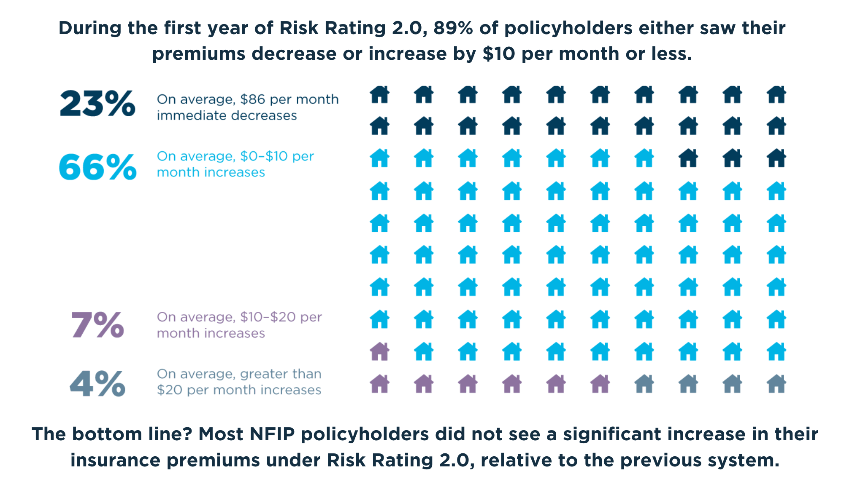

The real bottom line is that 77% of policyholders saw their policies stay the same or go up $120 or more per year and those policies will go up more than that every year until the Full Risk Rate is reached. Look at your policy and see if your premium (with the same coverage) is at the Full Risk Rate. The Full Risk Rate is how much RR 2.0 has determined the premium should be based on the risks they have projected. It may take ten years to get to that rate. If a policyholder lets the policy lapse, they will have to pay it in full to get back into the program. New houses can only buy a policy at the RR 2.0 rate. Homeowners with a federally backed mortgage that are newly mapped into a flood zone must have flood insurance and would pay full risk rates if they were not insured before the new zones were in place.

Why are the rates going up? The Federal Insurance and Mitigation Administration that runs the NFIP has changed the way that the premiums are calculated stating that the reason is to make premiums fair by eliminating subsidies and basing rates on the specific property’s risk.

Changes:
- The foundation of the RR 2.0 risk assessment is a catastrophic flood, not the 100-year flood risk used since the program began.
- RR 2.0 considers how far the structure is from a body of water that is a flood risk. This weighs more heavily in the premium calculation than the height.
- RR 2.0 no longer considers whether the structure is in the special flood hazard area.
- RR 2.0 considers how high the structure is from the ground without considering the flood map base flood elevation at all.
- RR 2.0 may provide credit for a levee between the water and the structure.
- RR 2.0 does not consider past flood claims unless there is a new claim. Then at the next renewal, the system will look at flood claims for the previous ten years.
- RR 2.0 uses private, proprietary data to guess the first-floor elevation, so no elevation certificate is needed.

Example: Property in Broadmoor with no history of flooding and no flood insurance claims
Old NFIP rate: C zone $519/year; new AE Zone ~$1,400/year (incremental increase over 5 years to get to full rate).
RR 2.0: Year 1 $613/year; year 12 $4,026 increasing 18% per year until at the full risk rate.

Background:

Though the Parish recently adopted new flood maps that set the base flood elevation that FEMA believes is safe from typical storms, the maps are not the key change to the new flood insurance rates. Flood insurance is necessary to protect our homes and businesses in Louisiana. Flooding can come from surge (like Katrina) or a hard rain (like Juan).

In 1968, after large storms convinced the private sector to abandon flood insurance policies, Congress created the National Flood Insurance Program (NFIP). The two primary goals were reducing future flood damage and protecting property owners. Policy holders entered into a partnership paying flood insurance premiums to the government run program that covered the claims most years, and Congress allocated funds when the program could not cover the damages. Congress borrows those funds from the Treasury, and the NFIP pays interest on those “loans.” Due to the large storms in the last decade, the payments and interest resulted in a debt of $20B. RR 2.0 was developed in part to make the NFIP self-sufficient by charging rates like a private for-profit insurance agency and to pay off the debt. The changes were made administratively which did not need approval from Congress. There has been no evidence provided to the Oversight Committees or the public proving that the methodologies to determine the risk and value of that risk are valid. The RR 2.0 program is under scrutiny from Congress and lawsuits have been filed.

